

Address: Door 1&2, RBD Bldg, Purok 7, Brgy. Ising, Poblacion, Carmen, Davao Del Norte Tel No. : (084) 822 1416

Cel No. : 09178995891 - Globe

Email Address: [e8enterprise@gmail.com](mailto:e8enterprise@gmail.com)







WE OFFER ELECTRICAL AND INDUSTRIAL SOLUTIONS



E & 8 Enterprise, started in the early part of 2018. The business started in Purok 7, Ising Carmen Davao Del Norte. Our first client is San Miguel Corporation and Unifrutti Tropical Philippines we offer Electrical and Industrial consumables. At first, we are offering electrical and services. To help us expedite the business, we first tapped friends, relatives and acquaintances. Seeking the good turnover of the business on Electrical, Lubrication and Industrial consumables. And immediately decided to expand the business around the Mindanao area.

Our company and its vast-sub-systems provide power life to the never-ending discoveries of the man. The compilation of engineering studies that incorporate together to provide solutions to every consumer needs whither in Lubrication, Industrial Innovations and Electrical Technologies.

E & 8 ENTERPRISE realizes the great importance of Engineering to man and industry. It is on this premise why the entity was formed. We also entrenched firmly with the able support of its professional managers and technical back up experienced engineers.

Our Marketing and Technical groups are ready to assist our clients in product identification, applicable usage and adaptation to existing systems. We maintained complete line of hardware stock inventory to ensure a one stop shop in your needs.

Our company aim to provide an incomparable good quality products and services that makes our clients with 100% return and recommend our company to their close family and friends. And assures the good quality, high standard and competitiveness with regards to our product. Quality and standard Product is our hallmark so that our customers deserve no less.

E & 8 ENTERPRISE make sure that not only great products and Services are to be meet but also provides very affordable and competitive price in the market.



E & 8 ENTERPRISE aims to be one of the leading service providers in the industry in terms of quality and cost saving. We will help every costumer enjoy life by providing fast and excellent customer services and maintain a socially-committed organization that would create sustainable employment.



To be able to deliver high quality solution to our customers, complying with the industry standard. To be able to maintain the standards set by the customers that are globally accepted. We commit to provide our dear customer with courteous and helpful services every time.





* ENGINE OILS, DIESEL OIL, GASOLINE OIL & MOTORCYCLE OIL
* GEAR TRANSMISSION OILS
* HYDRAULIC OILS
* GREASES (FOOD GRADE/ NON-FOOD GRADE)
* INDUSTRIAL GEAR OILS
* COMPRESSOR OIL
* SPECIALTY LUBRICANT/ FOOD GRADE OILS
* COOLANTS
* POWER STEERING FLUID
* FUEL FILTER
* LUBE FILTER
* OIL FILTER
* HYDRAULIC HOSE
* WATER SEPARATOR
* FUEL SEPARATOR
* HYDRAULIC FILTER
* AIR FILTER ELEMENT



* MOTOR CIRCUIT BREAKER
* INTEGRAL CONTRACTOR BREAKER
* MOTOR STARTER ELECTRIC SPOT STARTER, STAR DELTA
* OVERLOAD RELAY
* CONTACTOR (9A-150A) LCD1D
* PLUG IN RELAYS
* VARIABLE FREQUENCY INVERTER



* MINIATURE CIRCUIT BREAKER
* BOLT-ON MOLDED CIRCUIT BREAKER
* PLUG-IN CIRCUIT BREAKER
* CIRCUIT MONITORS
* DIGITAL METER
* VARPLUS LV CAPACITOR



* AMONIA GAS
* USED/BRAND NEW SACKS
* POLYNET
* OIL DISPENSER
* HAND TRUCK/HAND PALLET
* AERIAL BALL MARKER
* HAND HELD RADIO UHV/VHF
* ELECTRONIC PARTS
* GENERATOR SETS
* OXY/ACHEY
* HELIUM
* NITROGEN
* HARD TO FIND ITEMS



## ELECTRICAL WORKS- DESIGN AND INSTALLATION

* POWER GENERATING UNIT
* POWER SUBSTATION
* MOTOR CONTROL CENTER
* AUTOMATION AND CONTROL CENTER
* CAPACITOR BANK
* DISTRIBUTION PANEL
* GENERATOR & TRANSFORMER
* ELECTRICAL MAINTAINANCE

## CIVIL/MECHANICAL WORKS- FABRICATION & INSTALLATION

* PIPE INSTALLATION/FABRICATION
* MECHANICAL EQUIPMENT INSTALLATION
* MECHANICAL EQUIPMENT REHAB
* AIR DRYER/ CHILLER REPAIR/RECON
* STEEL FABRICATION
* CLADDING/INSTALLATION
* PANELING WORKS
* CONVEYOR STEEL WORKS & ETC

DESIGN, FABRICATION & MANUFACTURING OF PREWIRED PANELS

* PREWIRED MEDIUM VOLTAGE SWITCH GEAR
* PREWIRED MOTOR CONTROL CENTER
* PREWIRED MAIN DISTRIBUTION PANEL
* PREWIRED CAPACITOR BANK
* PREWIRED AUTOMATIC/MANUAL TRANSFER SWITCH
* LIGHTING PANEL AND PANEL BOARDS
* ENCLOSED CONTROL STARTERS
* S/S & MS PLATE CABLE TRAY, WIRE GUTTERS, METAL ENCLOSURE



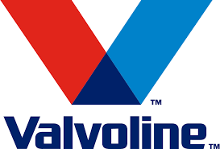









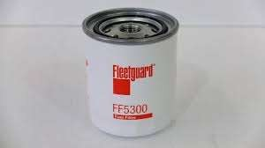

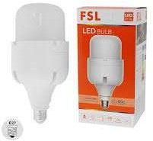





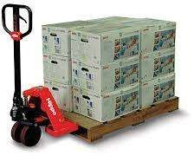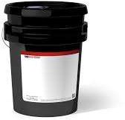

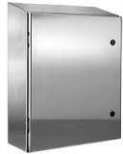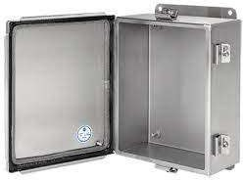

 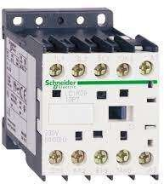

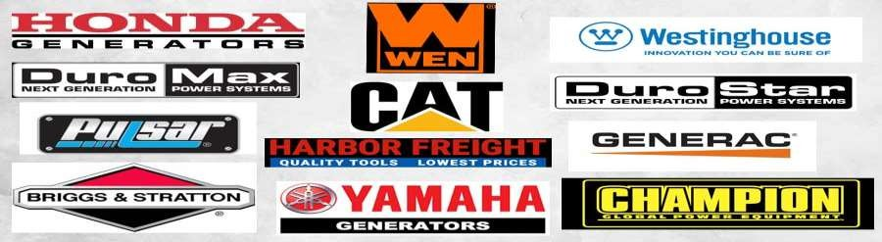

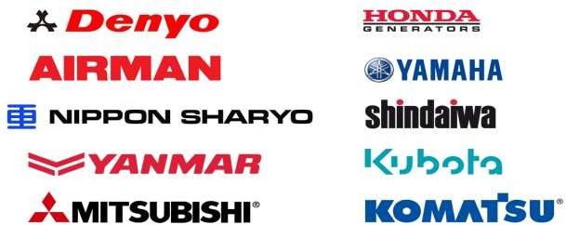

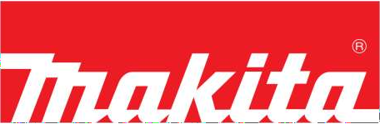

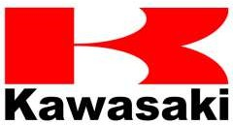

 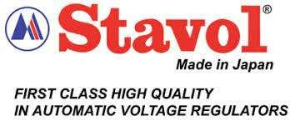











U-DEV CORPORATION

**U C**

















# EDMON ALLAN J. TIEMPO

Position: General Manager

Address: Purok 5 Mangalcal Carmen Davao Del Norte

***Overall Nature of Work Responsibilities***

Over Twenty (20) years of experience in the field of marketing, selling and quality management. And now, eager in the field of engineering expertise in the Design, Installation and Maintenance, Power and Instrumentation in both Commercial and Industrial Establishment.

### Personal Information

Age : 43

Sex : Male

Civil Status : Married

Nationality : Filipino

### Educational Background

Bachelor of Science in Commerce Financial Management Major University of Mindanao

### Experience Information

#### Sidewall Engineering Sales & Service

Operation Manager

#### Mechanical Handling Equipment Inc.

Sales Engineer

Makati city Metro Manila

**Fluid Solution Inc.** Lubricant Consultant Pasig City, Metro Manila

# ENECITA FIGURO ALFECHE

Position: General Admin/Proprietor Address: Purok 5, Brgy. Mangalcal Carmen

Davao Del Norte

### Personal Information:

Age : 35

Sex : Female

Civil Status : Single Nationality : Filipino

### Educational Background:

#### Bachelor of Science in Hotel and Restaurant Management

University of Taguig Taguig Metro Manila

#### Computer Technician

ADTECH PASAY

Pasay Metro Manila

### Experience Background:

#### Koin Inc.

Product sourcing Specialist Amazon USA

5th Ave. New York

#### CONSTRAT INC.

Admin/Accounting Staff Paranaque Metro Manila

**Markonsult Inc.** Admin Assistant Pasay Metro Manila

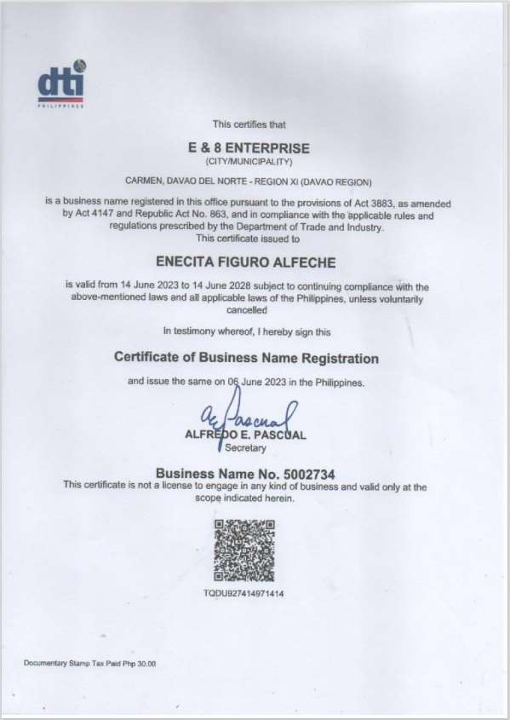

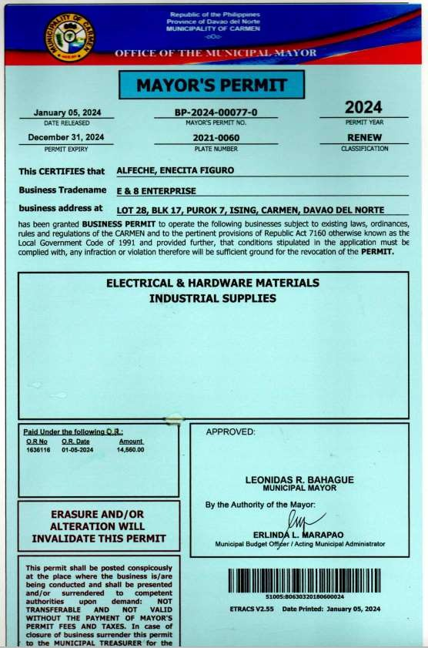

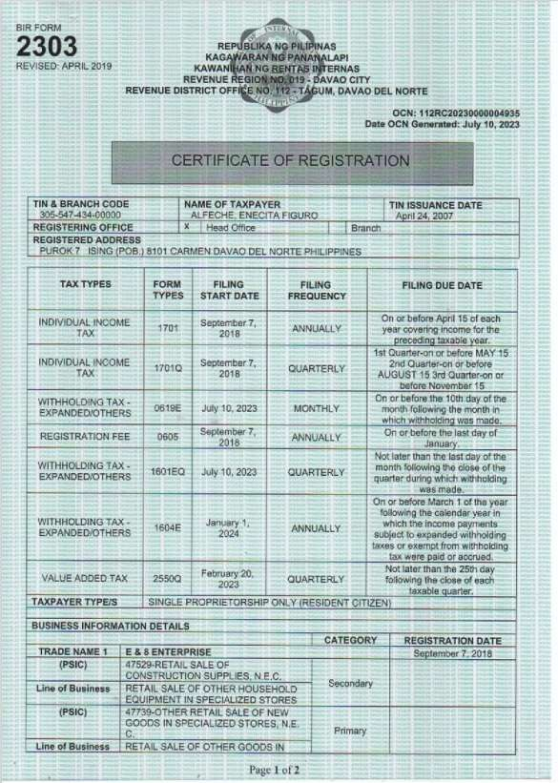

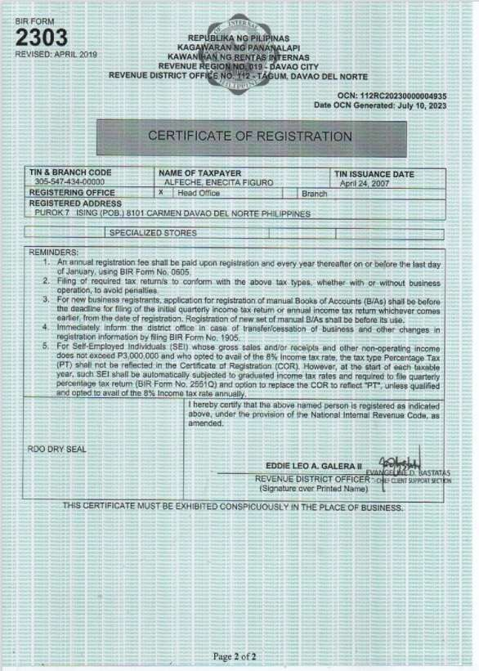

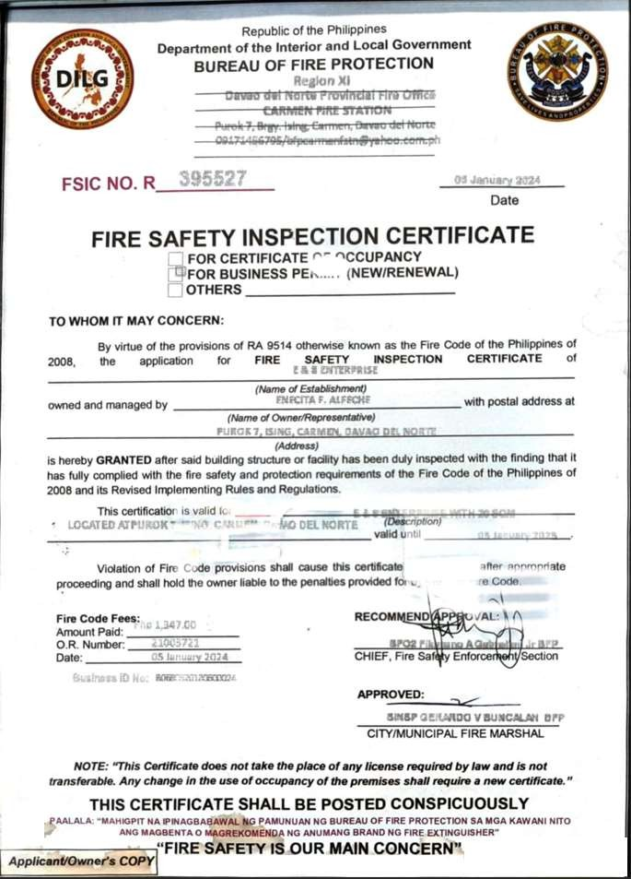

V

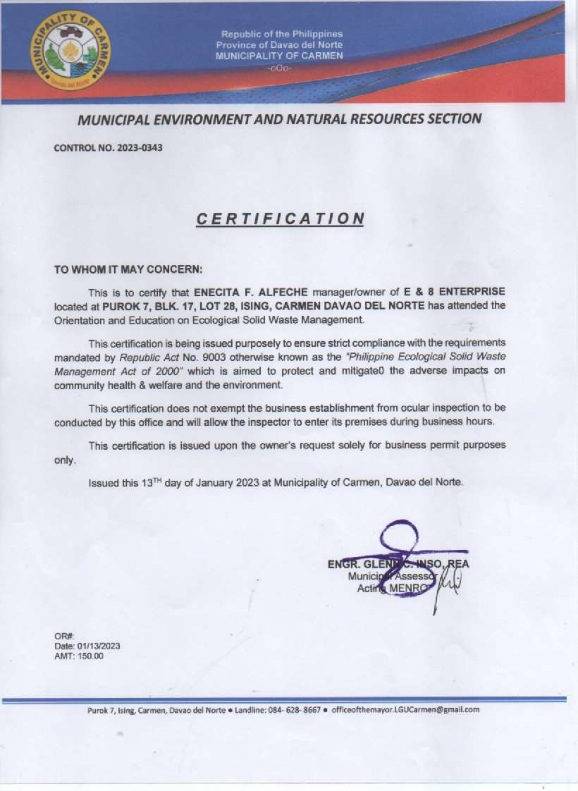

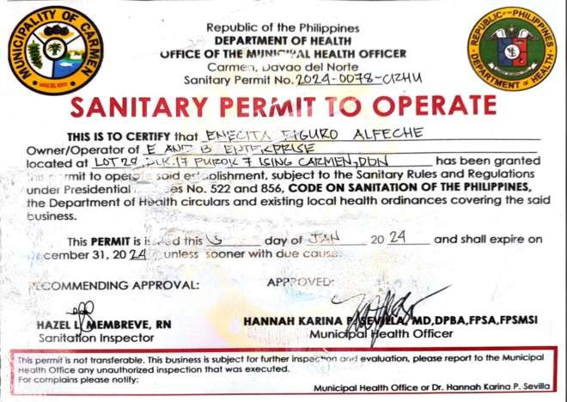

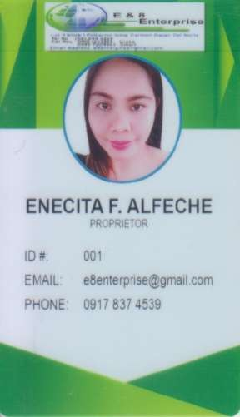 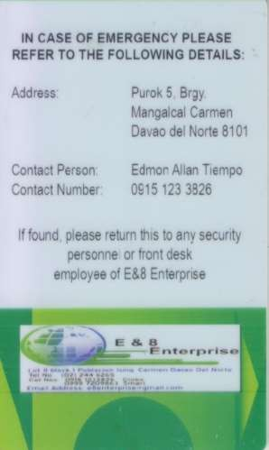

**LOCATION MAP**

MAHARLIKA HIGHWAY

## CARMEN PUBLIC TRANSPORT TERMINAL

FLYING – V GASOLINE

TAGUM COOPERATIVE

LESS & MORE SUPERMARKET

ROJON PHARMACY

POWER DYNAMIC

ENTERPRISE – *Hardware Store*

ROSE BAKESHOP

**E&8 ENTERPRISE**



THIS SITE